How to submit work on Connect –
*Please ensure that you are logged in to your child’s account and not on your parent/guardian account, you cannot submit work on a parent/guardian account.
*Please be patient, Connect is running slow as there is a high usage – Please try submitting at a later time if it is not working at the present time.
If your child does not know their login, please contact the school on 9553 0100.
- Log in to Connect using the following:

Username: Joe.bloggs (Student first name.student last name)
Password: Should have been given by the teacher

If you have forgotten the password, please select the ‘Forgot Password’ link or contact the school on 9553 0100 to be reset.

- Once logged in, the home screen should display the list of your child’s classes.
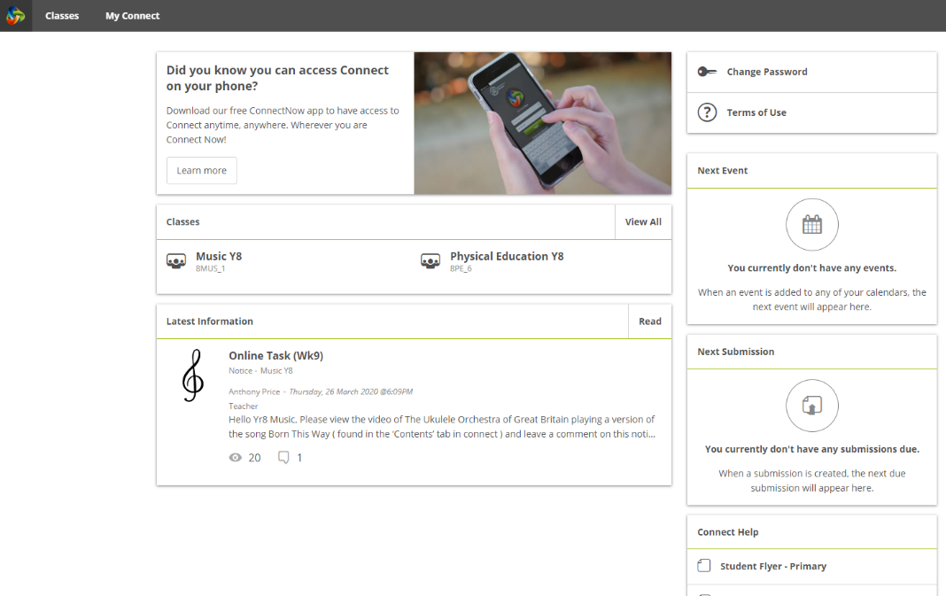

- Click on the class you are submitting work for and this will open the class and its contents.
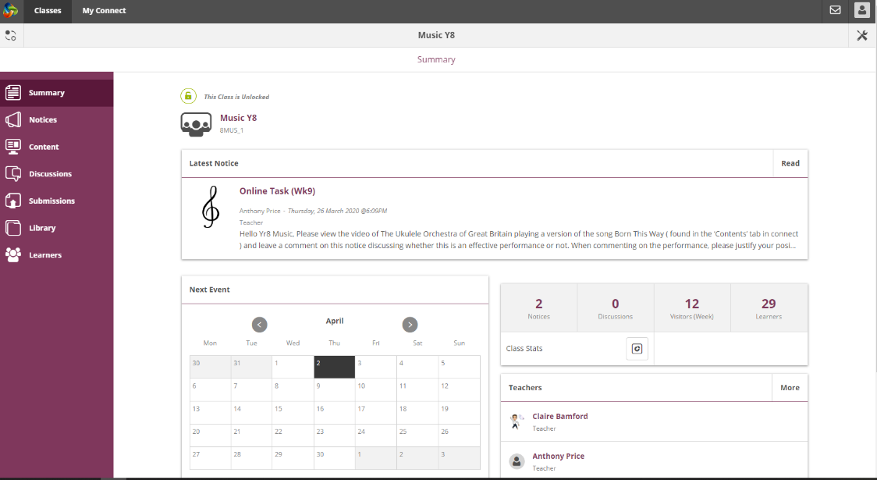

- On the left hand side of the page, Select the Submissions Tab.

This will bring up all assessments due for that class.

- Click the Submit Work button for the assessment you wish to submit.
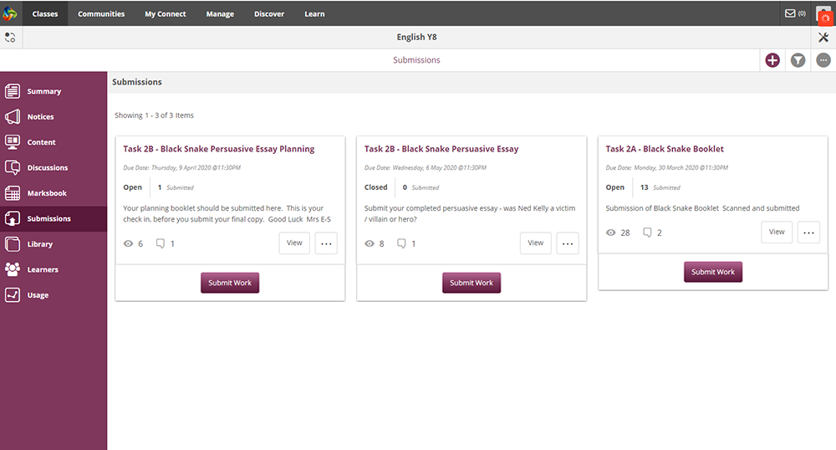
- Select Upload Submission, this will bring up your document folder where you can choose your work to upload.
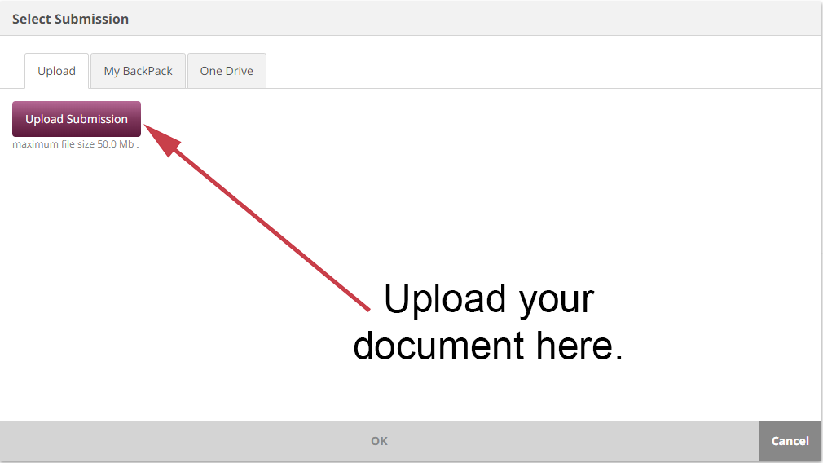

Other options for submitting work –
Scan paperwork and Upload to Connect
Scan paperwork and email to class teacher
Take a photo of your work and email to class teacher
Drop it into school (If you have signs of COVID-19 or have been in contact with someone who has symptoms, please do not come in)

